**Definition: Use incorporate shadows and blur into your design.**

**Solution:**

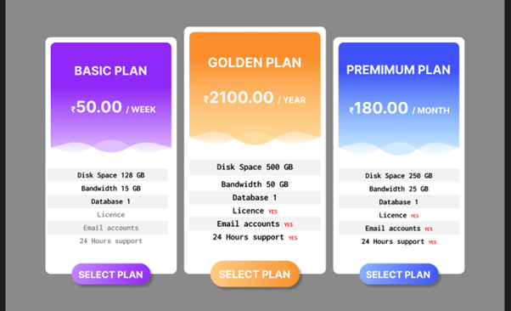

**Steps:**

* First Open Figma in browser mode.
* Then create the new document **File à New Figma Design.**
* Now add one frame using the Frame tool with width=”**950px”** and height=”**675px”** on your canvas.
* **To make Basic Plan:**
* Now in one rectangle draw 2 rectangles of width=**”230px”** and height=**”220px”** shape both rectangles bottom line like a wave. Fill one rectangle with linear color ” #**9029F7**” and “#**7B668F**” which will be on top of second rectangle fill second rectangle with “#**E1BEFF**”.
* Take a text tool and write “**BASIC PLAN**” over these two rectangles with font=”**23**” and color “#**FFFFFF**”, also write “**₹50.00 / WEEK**” with font=”**30**” and color “#**FFFFFF**”.
* Now below the rectangles write a given value in a vertical line in the center of the main rectangle with font=”**30**”.” Disk **Space 128 GB**”, “**Bandwidth 15 GB**”, “**Database 1**”, “**License**”, “**Email accounts**”, “**24 Hour's support**”. Give the first three text color “#**000000” and** second three color “#**7F7F7F**” to make it look like disabled features.
* Now to make the purchase button take a rectangle of width=”**180px**” & height=”**25px**” fill linear color “#**9029F7**” and “#**C387FC**”. Use text tool and write “**SELECT PLAN**”

* **To make Premium Plan:**
* Now in one rectangle draw 2 rectangles of width=**”230px”** and height=**”220px”** shape both rectangles bottom line like a wave. Fill one rectangle with linear color ”#**9029F7**” and “#**7B668F**” which will be on top of second rectangle fill second rectangle with “#**E1BEFF**”.
* Now in one rectangle draw 2 rectangles of width=**”230px”** and height=**”220px”** shape both rectangles bottom line like a wave. Fill one rectangle with linear color ”#**3F52F9**” and “#**3F9CF9**” which will be on top of second rectangle fill second rectangle with “#**D2EBFF**”.
* Take a text tool and write “**PREMIUM PLAN**” over these two rectangles with font=”**23**” and color “#**FFFFFF**”, also write “**₹180.00 / MONTH**” with font=”**30**” and color “#**FFFFFF**”.
* Now below the rectangles write a given value in a vertical line in the center of the main rectangle with font=”**30**”.” Disk **Space 128 GB**”, “**Bandwidth 15 GB**”, “**Database 1**”, “**License**”, “**Email accounts**”, “**24 Hour's support**”. Give the text color “#**000000**”.
* Now to make the purchase button take a rectangle of width=”**180px**” & height=”**25px**” fill linear color “#**3F52F9**” and “#**3F9CF9**”. Use text tool and write “**SELECT PLAN**”.

* **To make Golden Plan:**
* Now in one rectangle draw 2 rectangles of width=**”250px”** and height=**”220px”** shape both rectangles bottom line like a wave. Fill one rectangle with linear color ”#**FA8F2C**” and “#**FFDDA1**” which will be on top of second rectangle fill second rectangle with “#**FFDDA1**”.
* Take a text tool and write “**GOLDEN PLAN**” over these two rectangles with font=”**25**” and color “#**FFFFFF**”, also write “**₹2100.00 / YEAR”** with font=”30” and color “#**FFFFFF**”.
* Now below the rectangles write a given value in a vertical line in the center of the main rectangle with font=”**30**”.” Disk **Space 128 GB**”, “**Bandwidth 15 GB**”, “**Database 1**”, “**License**”, “**Email accounts**”, “**24 Hour's support**”. Give the text color “#**000000**”.
* Now to make the purchase button take a rectangle of width=”**180px**” & height=”**50px**” fill linear color “**#FA8F2C**” and “**#FFDDA1**”. Use a text tool and write “**SELECT PLAN**”.
* Now, Go to the **Export** button in the property panel. And **Export** it with .**JPG/.PNG** format.